AI / Non-AI Collaboration Log – Task-Based Template
Complete one log for each major milestone of your project (min. 4 logs total).
Maximum 2 logs per week. Each log should take ~10–15 minutes.
Choose and fill either Path A (AI) or Path B (Non-AI) for each milestone and omit the other, depending on what you used.

Milestone Categories (choose one for each log)
- Planning & Research – defining goals, gathering requirements, outlining scope.
- Design & Architecture – creating structure, workflows, and initial prototypes.
- Core Development – building main features, core functionality, and foundational systems.
- Integration – connecting components, services, or data sources.
- Quality Assurance – testing, debugging, and refining functionality.
- Optimization – improving performance, usability, and efficiency.
- Finalization & Delivery – polishing, documentation, deployment, and handoff.

Log Entry # _3_
Milestone Category: quality assurance
Date / Week: __________12/5/2025________
Commit ID / Screenshot link: 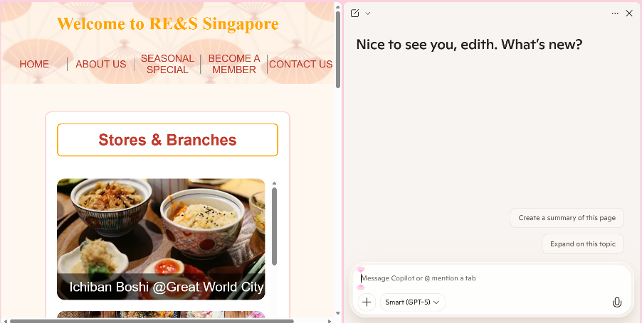3ff3eb441d9af84e93f35a74ad2c50aa4dc2ea71

Path A – If you used AI
- Task Description
(1–2 sentences about what you worked on)
Example: “Integrated the weather API and displayed results in a card layout.”
I used ai to help me check the responsiveness of the css file.

- AI Input
(Paste 1 AI prompt + 1 snippet of AI output, Share your AI conversations with the share button, share the entire history of the AI chat not the response only.)
Check the css to see if it can fit smaller screens without any weird distortion.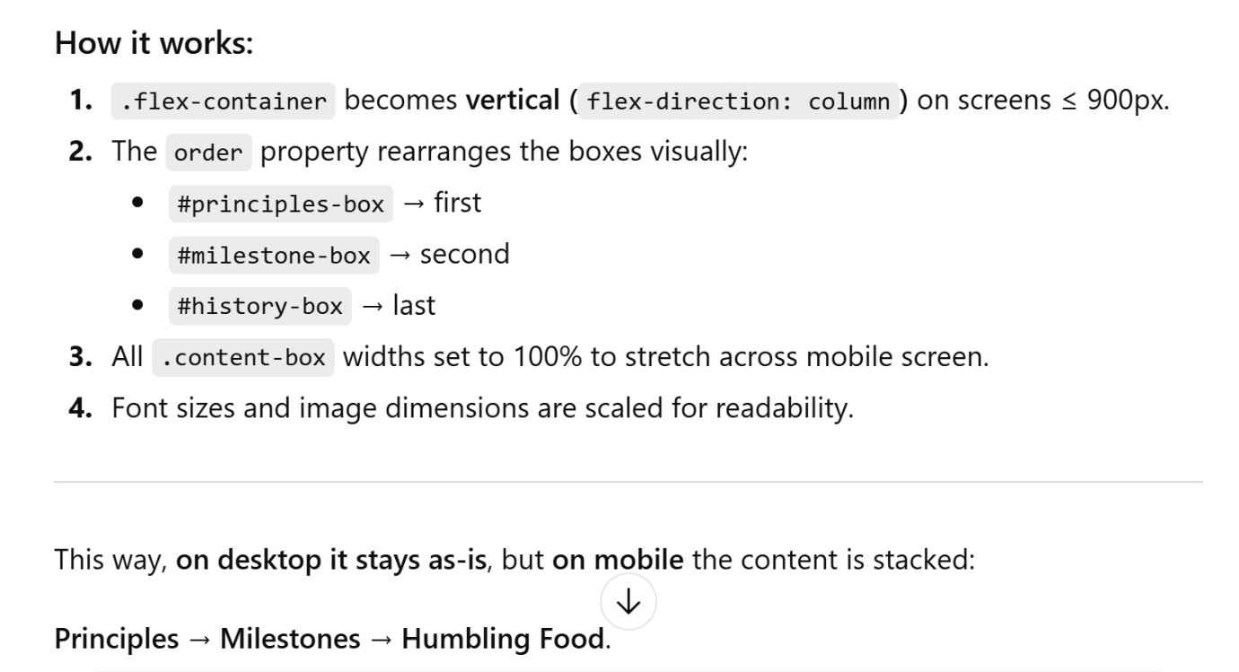

- My Edit / Change
(1–2 sentences: What you modified, why, or what you learned)
Example: “AI didn’t handle API errors. I added try/catch to manage missing data.”
I change the padding/sizes to fit my satisfactions.

- Reflection Prompt (choose one / add your own)
  - What mistake did AI make, and how did you spot it?
  - What did AI do better/faster than you?
  - What unique decision did you add that AI couldn’t?
  - How would you explain this feature to a non-coder in 2 sentences?
Apart from running through, ai fixes mistakes I made in the css code. And ai also gave me ideas on how the responsiveness can affect certain screens and what should be better.

Path B – If you did not use AI
- Task Description
(1–2 sentences about what you worked on)
Example: “Created responsive navbar with media queries.”

- Support Source Used
(Document what helped you: docs, tutorials, peers, debugging)
Example: “I used MDN docs on flexbox and StackOverflow for media query syntax.”

- My Edit / Change
(1–2 sentences: What you modified, why, or what you learned)
Example: “The tutorial used px units, I switched to rem units for accessibility.”

- Reflection Prompt (choose one / add your own)
  - What mistake or confusion did you find in the resource, and how did you resolve it?
  - What did the resource help you do more quickly?
  - What unique decision or creativity did you add that wasn’t in the resource?
  - How would you explain this feature to a non-coder in 2 sentences?

